Exercise 9.1.1
- Write a simple ARMlite assembly program that draws a single line of the same length across the second row (starting from the left-most column) in Low-res display mode.
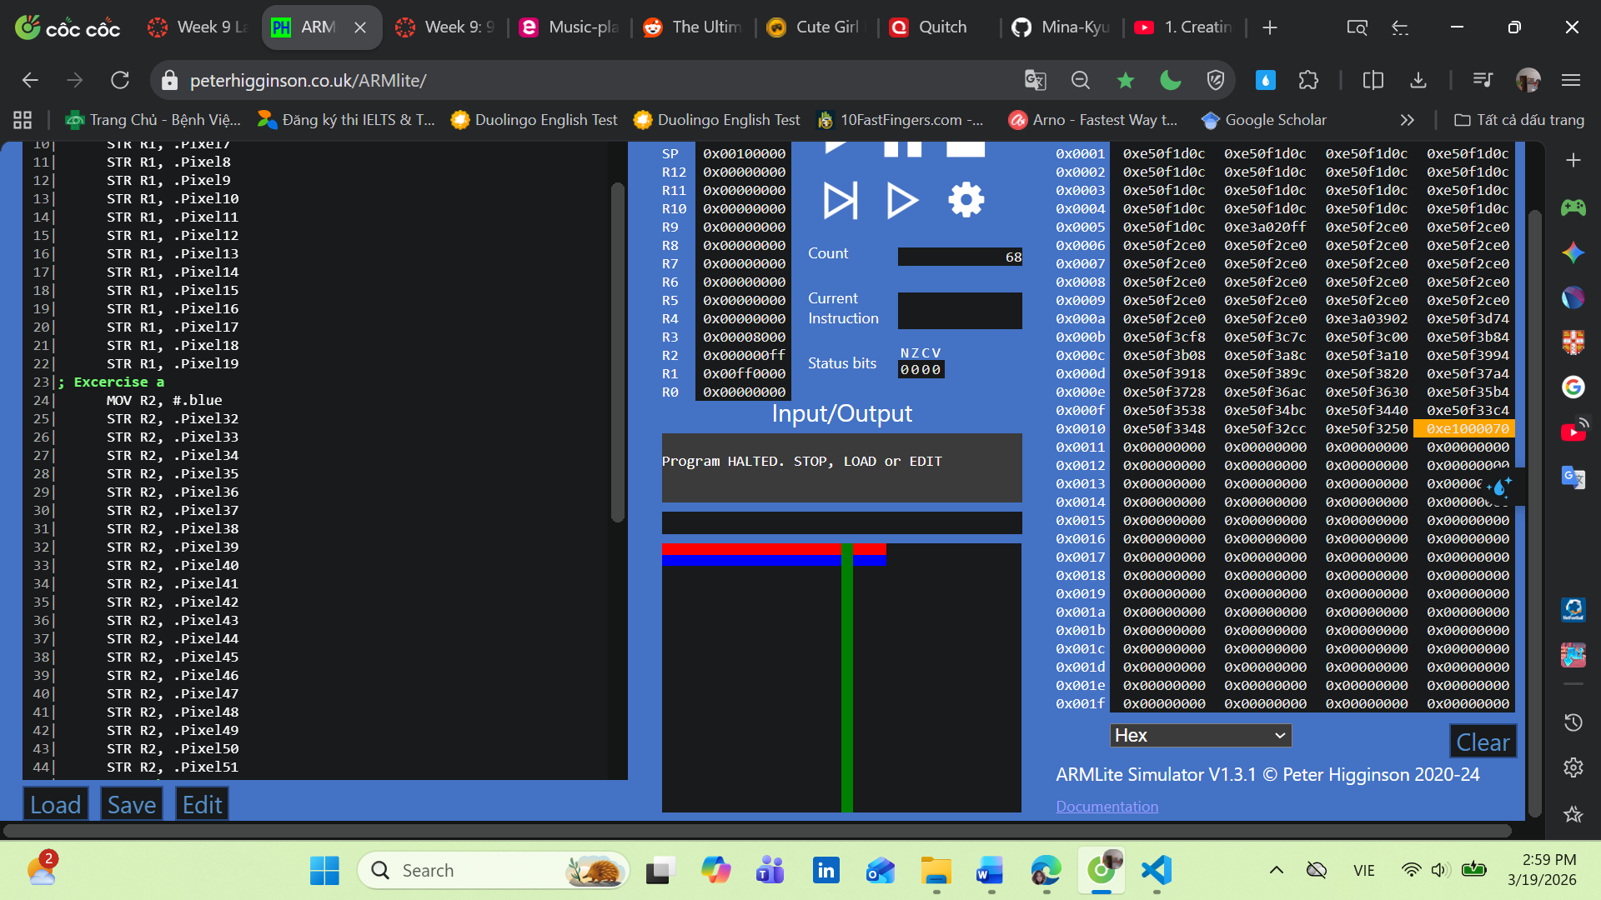
- Add to your assembly program code that draws a single line of the same length vertically, down the middle of the display in Low-res display mode
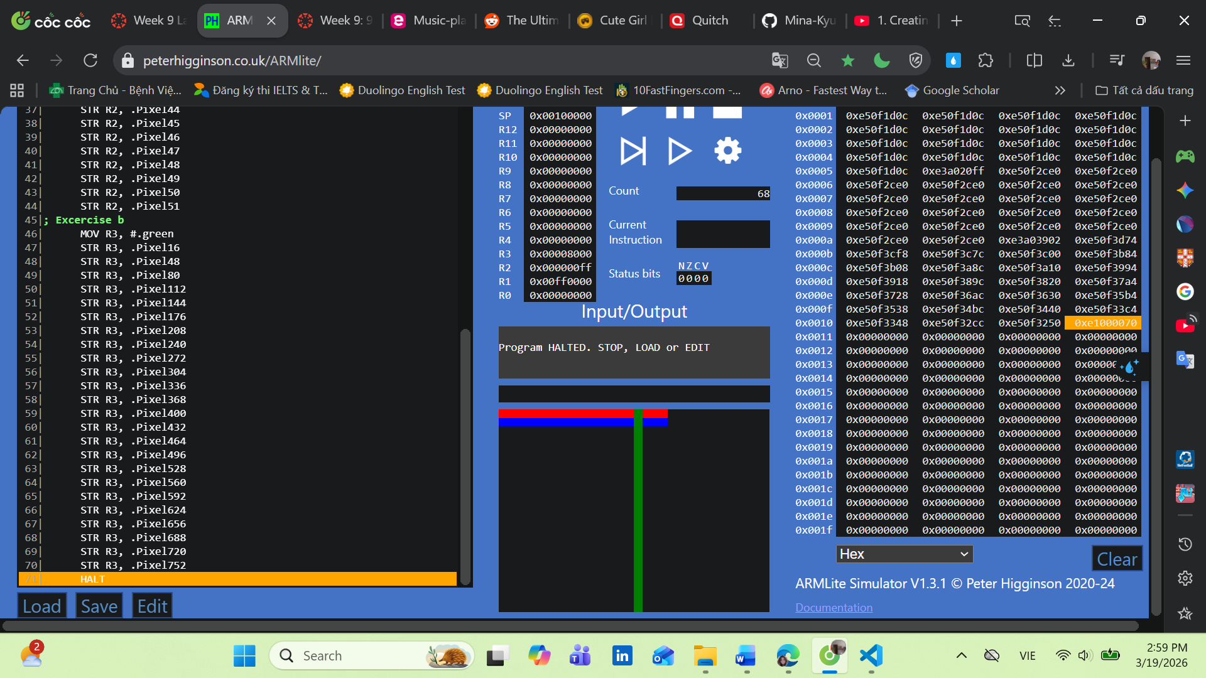
Once complete, show your lab demonstrator, and take a snap shot of your screen and include in your lab submission document

Exercise 9.1.2
Exercise 9.1.3
- Explain what specifically makes this code an example of indirect addressing ? How is it using indrect addressing to draw each pixel ?
The code demonstrates indirect addressing because memory addresses are not explicitly specified. Instead, they are computed dynamically:
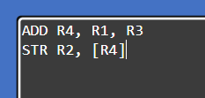
Where:
- R1 stores the base address
- R3 is the offset
- R4 holds the computed effective address
The syntax [R4] indicates memory access via a register-stored address.

- Once you're confident yo understand the code, modify the program so that it draws a line of the same length along the second row of the Mid-res display.
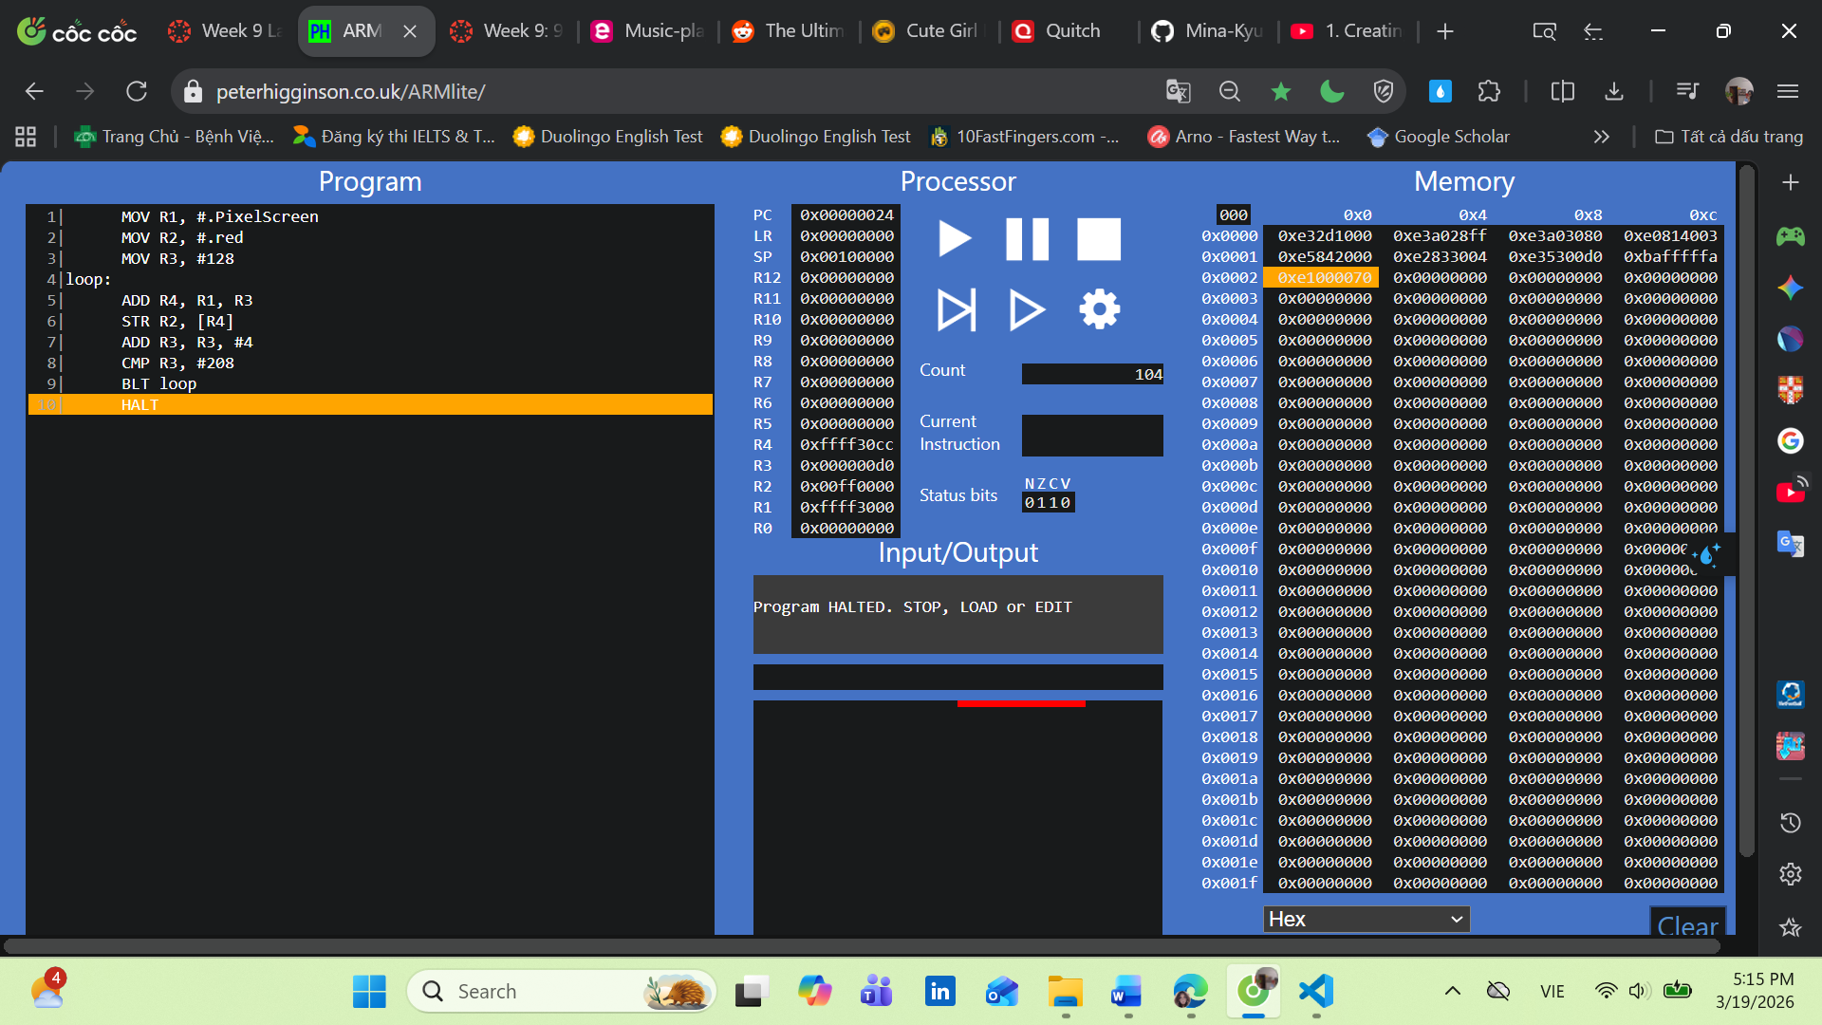
- Further modify your program so that it also draws a line of the same length vertically down the middle of the display.
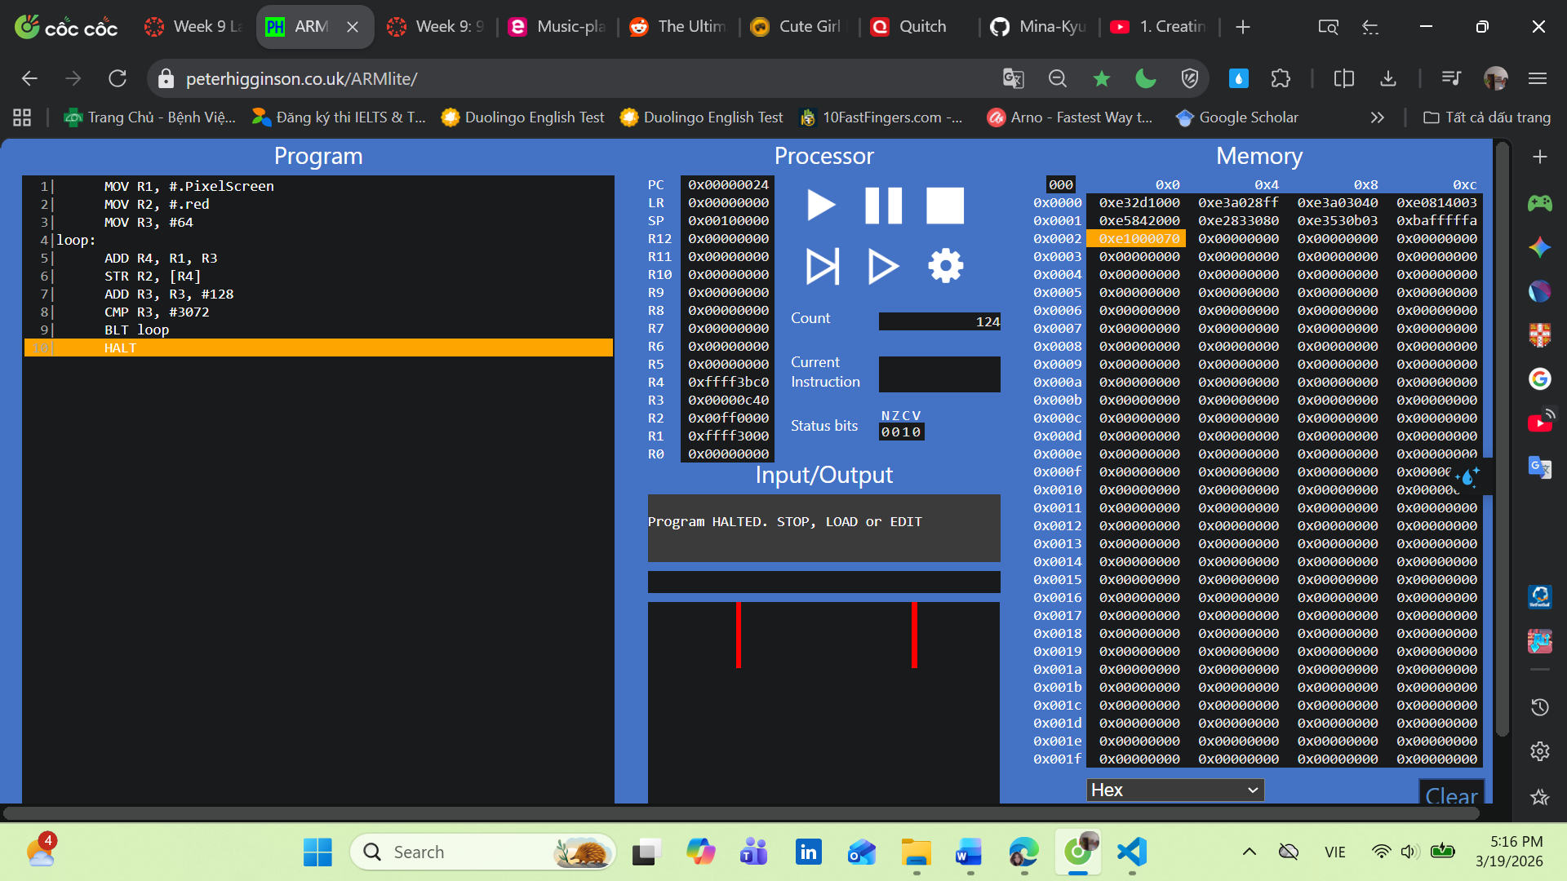
Once complete, show your lab demonstrator, and take a snap shot of your screen and include in your lab submission document
Excercise 9.2.1
In ARMlite, rewrite the code above so that is uses indexed addressing to draw the line in Medium-res display mode.
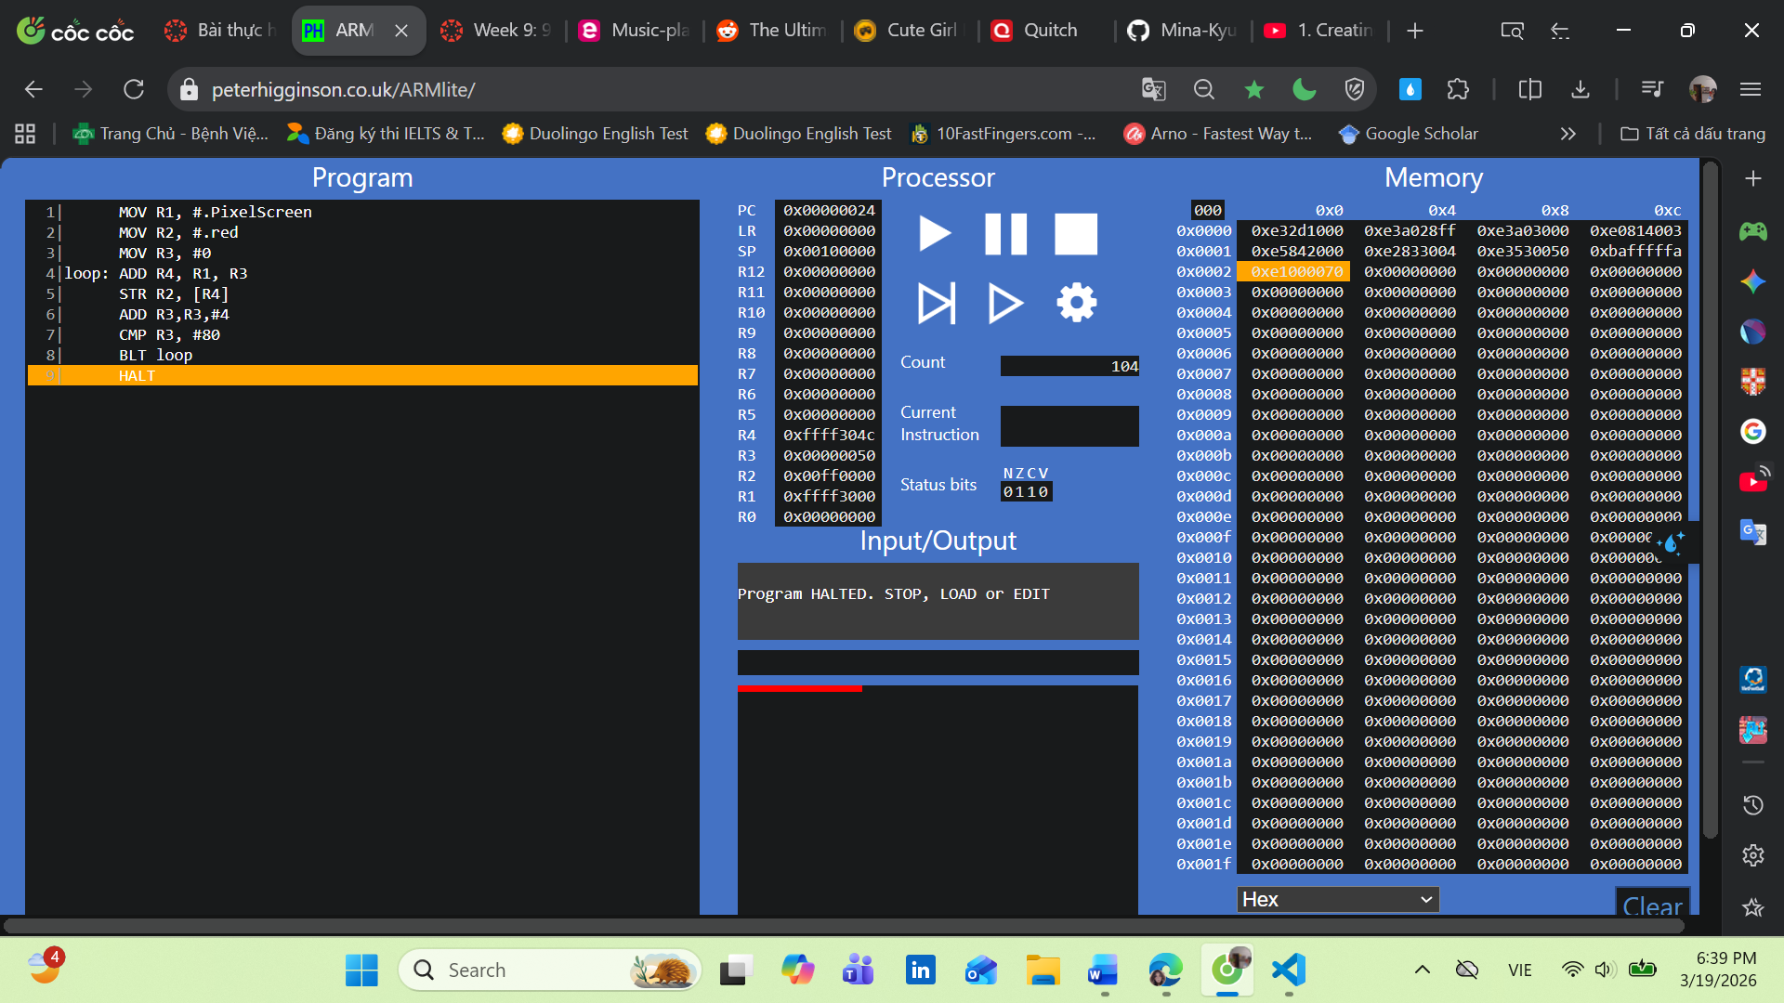
Copy and past a screenshot of your code and correct output into your submission document.
Excercise 9.2.2
When complete, copy and past a screenshot of your code and correct output into your submission document.
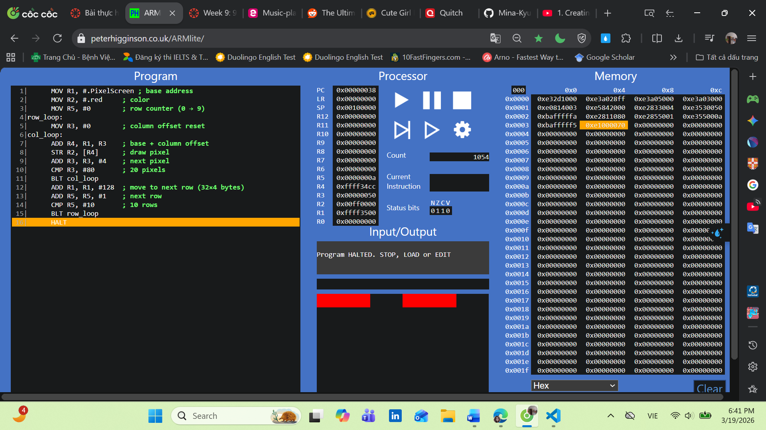
Excercise 9.3.1 (a)
The above code defines an array of 10 32 bit integers. What is the purpose of the .Align 256 instruction ?
The .ALIGN 256 directive ensures that the next data is placed at a memory address that is a multiple of 256. Purpose:
- Ensures proper memory alignment
- Improves access efficiency and correctness
Note: if you try and execute this program as it is above, it will cause an error on Line 2 (Uknown Instruction). Why is this ? (HINT: think about what is in memory at that point of the program)
After .ALIGN 256, the following line:
arrayLength: 10
is data, not an instruction
The CPU attempts to execute it as code
→ resulting in an "Unknown Instruction" error
Excercise 9.3.1 (b)
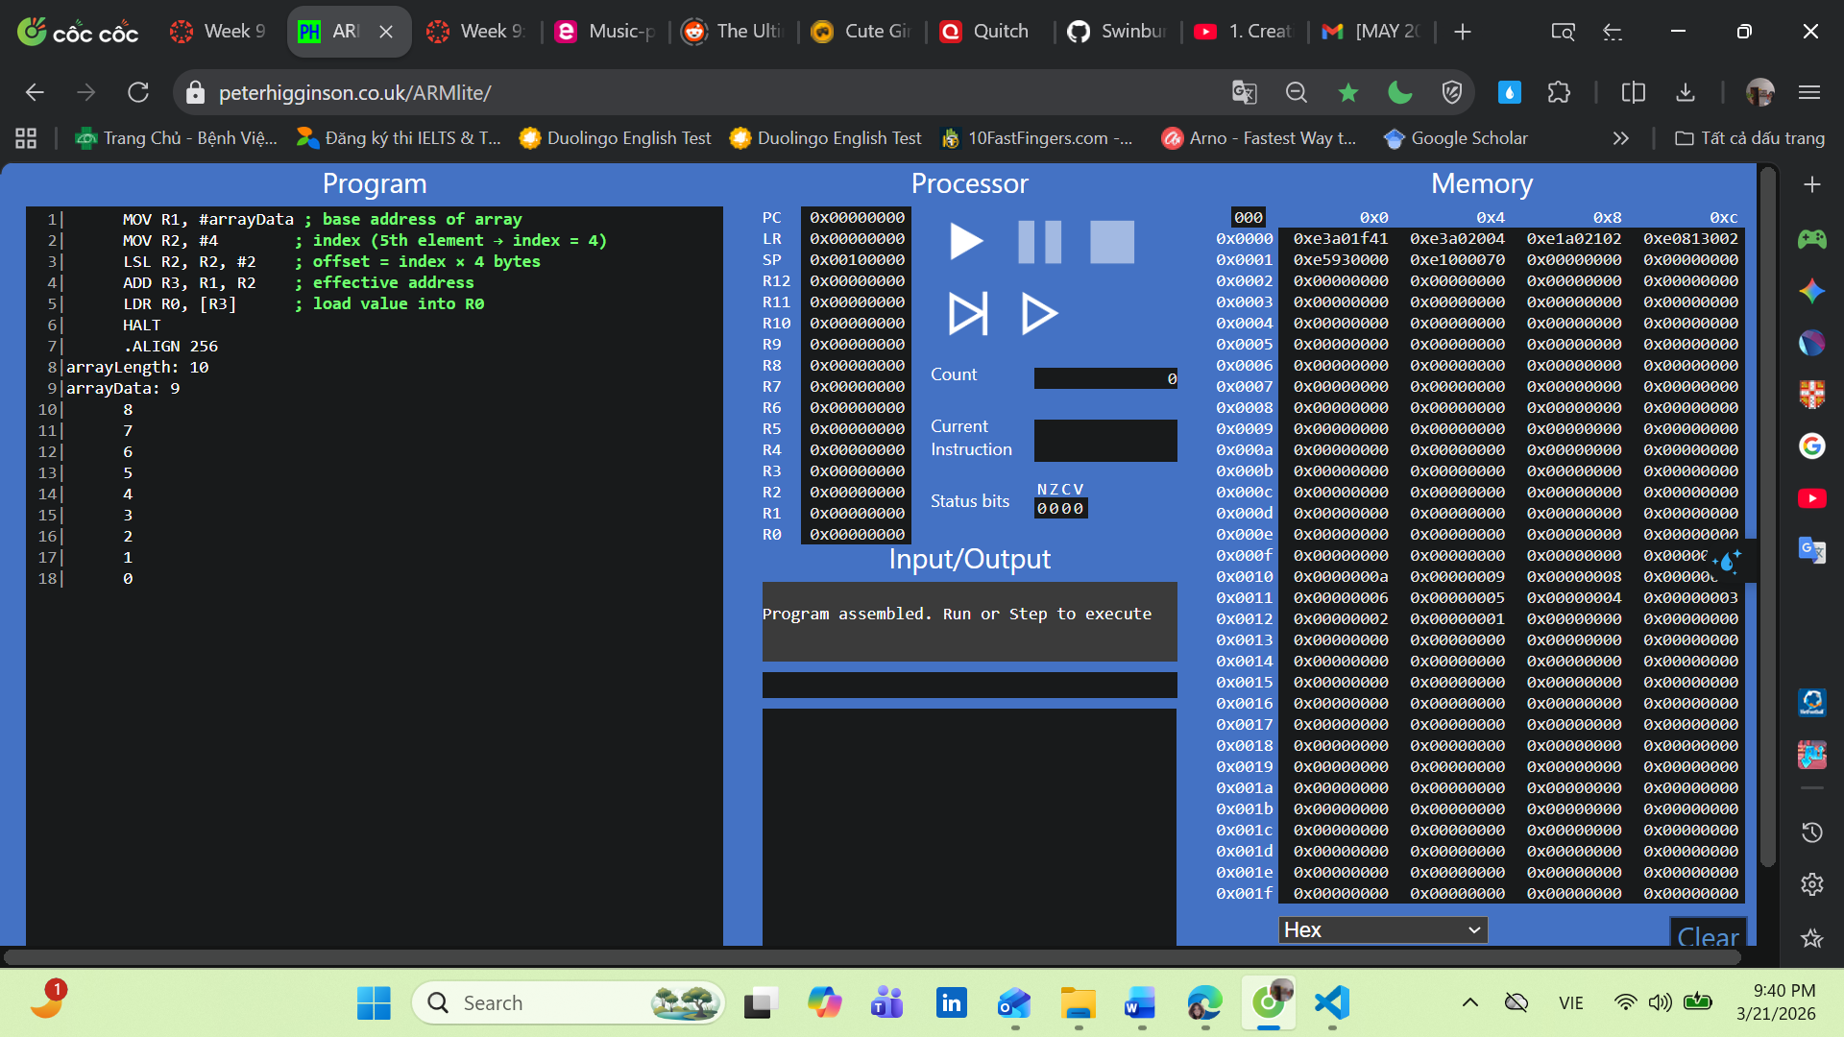
The 5th element in the array has index = 4 (0-based indexing).
Each element occupies 4 bytes, therefore the offset is:
offset = index × 4 = 16 bytes
The address of the element is calculated as:
address = base + offset
The value at this address is then loaded into register R0.
Excercise 9.3.1 (c)
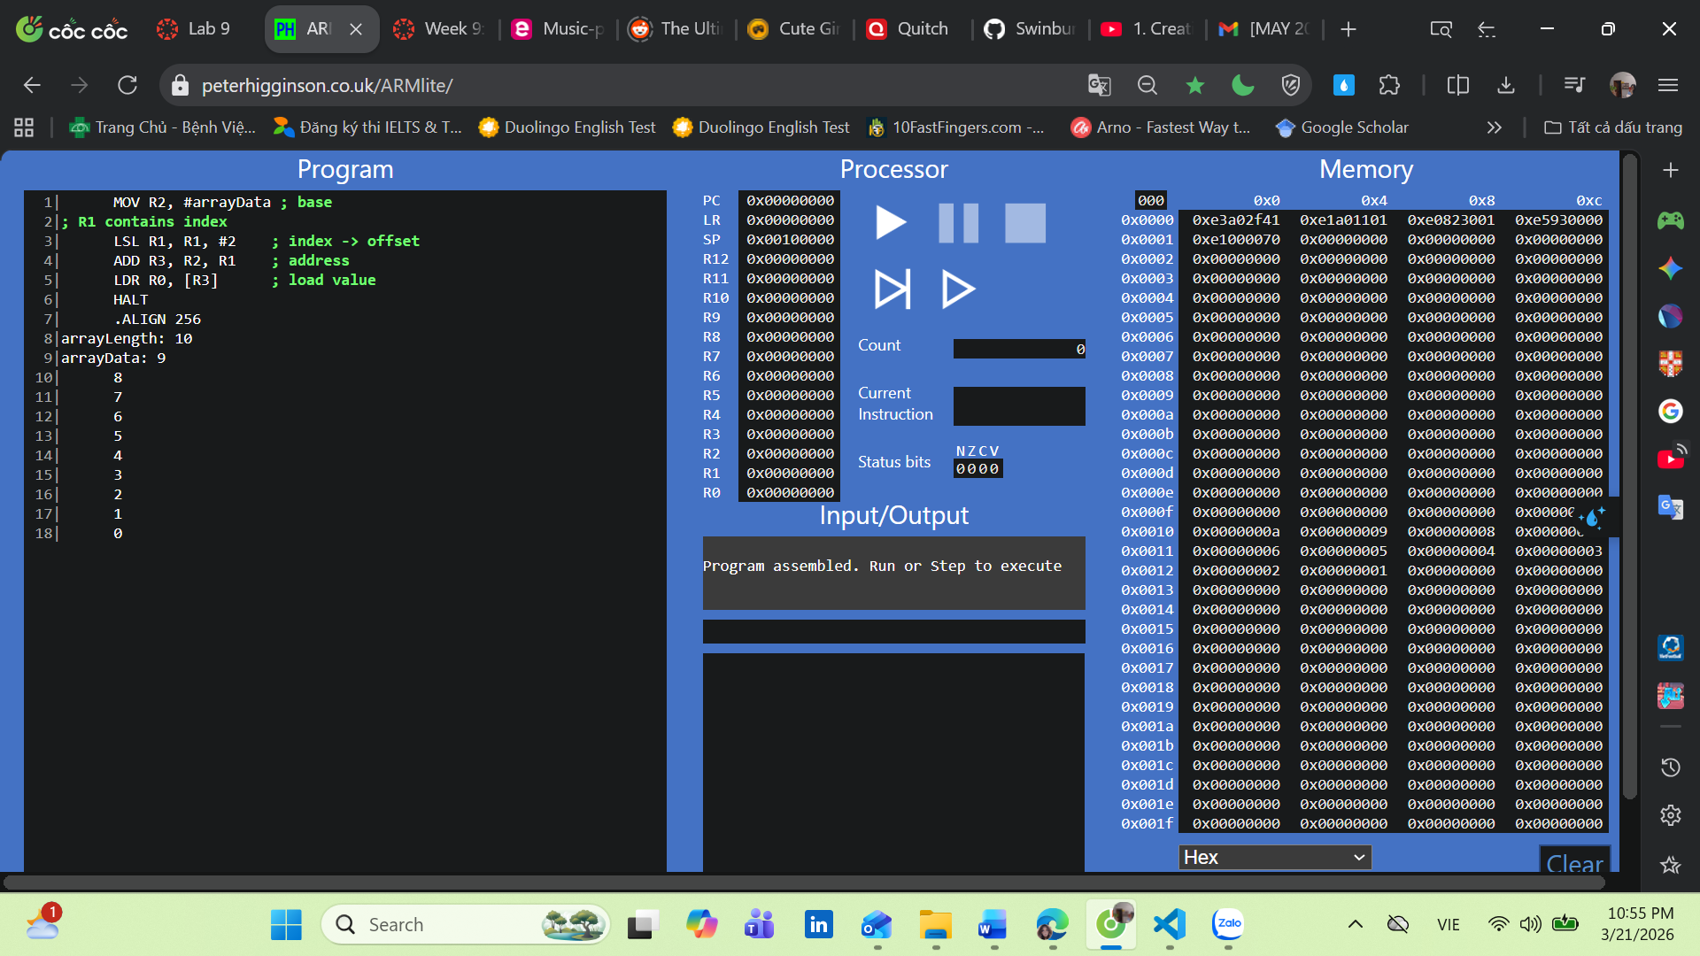
Take a screen shot showing the code and output, and include in your submission document.
Since R1 stores the index (not the byte offset), it must be converted:
offset = index × 4
This is done using:
LSL R1, R1, #2
The effective address is then computed as base + offset, and the value is loaded into R0.
R1 is assumed to contain the index value provided at runtime.
Excercise 9.3.2
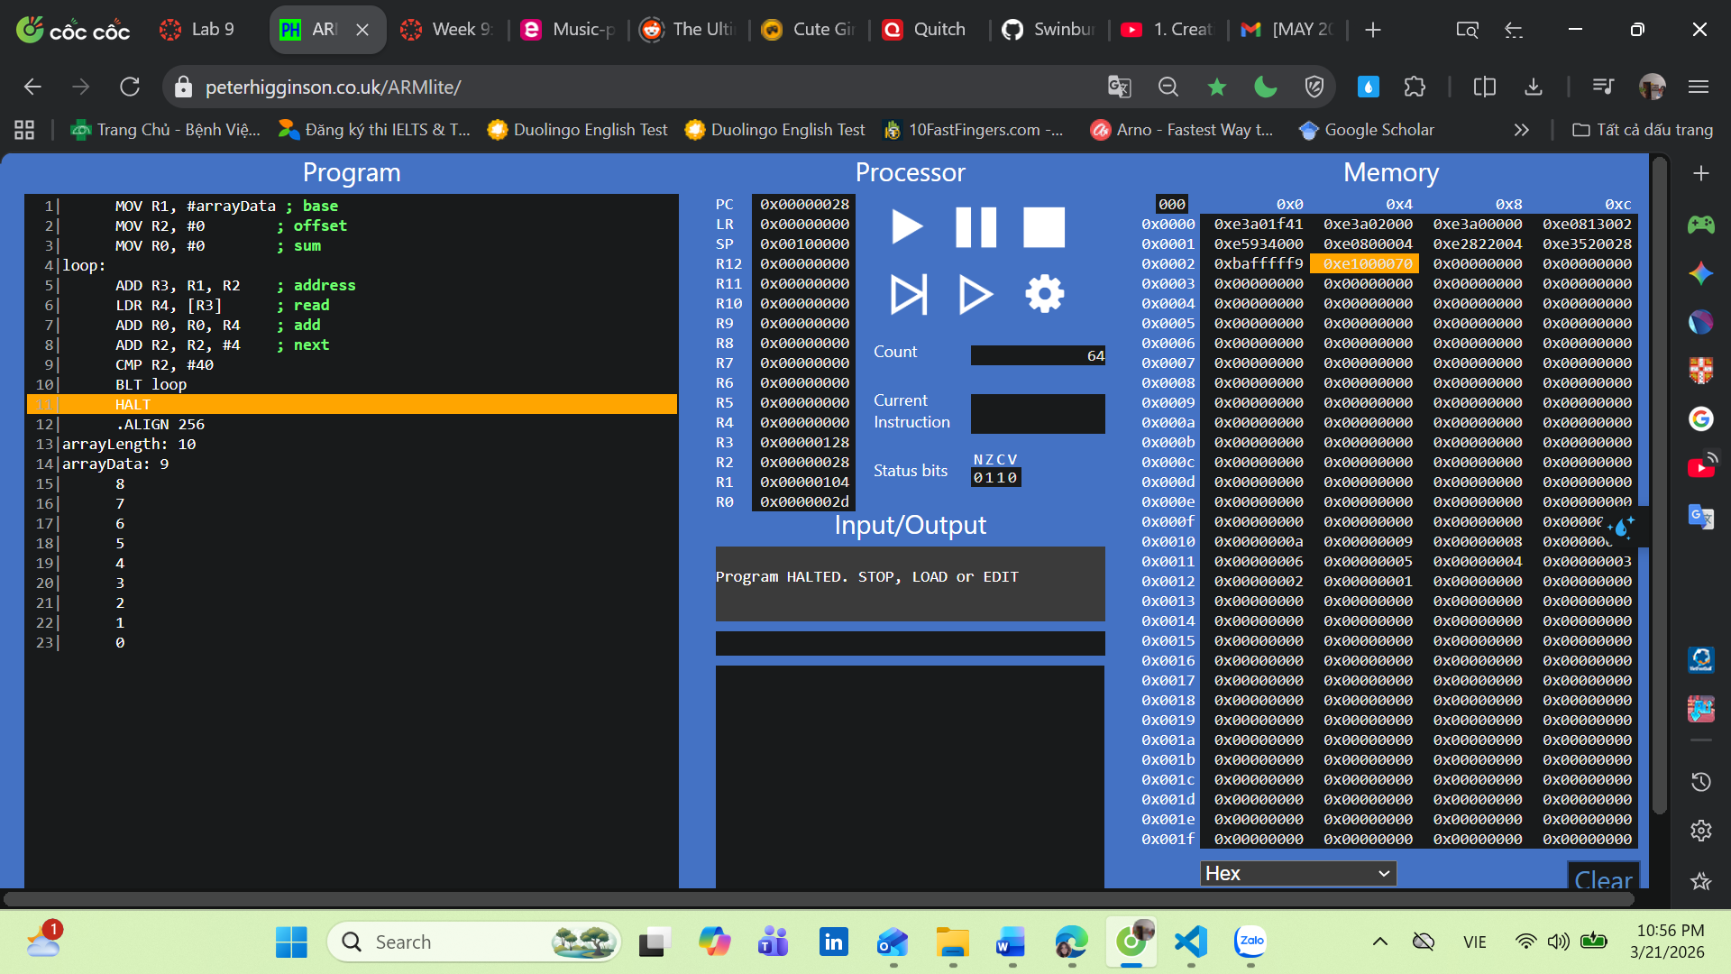
Take a screen shot showing the code and output, and include in your submission document.
Excercise 9.4.1
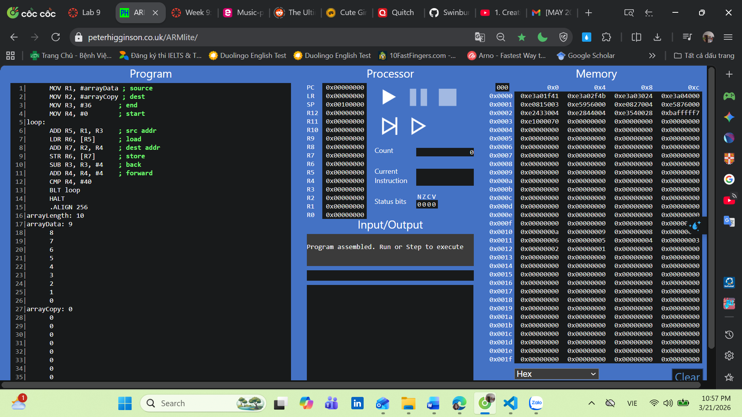
Once complete, show your tutor the executing program, and take a screen shot showing the code and output, and include in your submission document.
Excercise 9.4.2
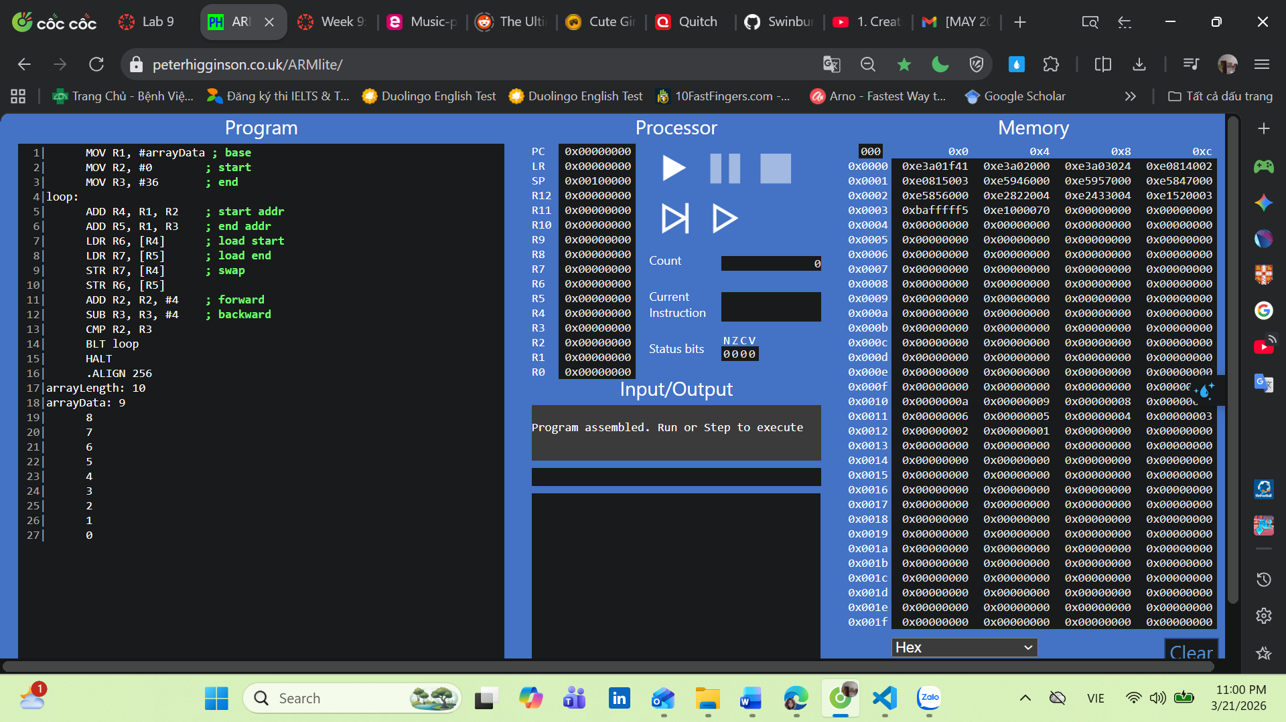
Once complete, show your tutor the executing program, and take a screen shot showing the code and output, and include in your submission document.

